

By : Techuva Solutions

Privileges

## Index

|  |  |  |
| --- | --- | --- |
| S.No. | Privilege Roles | Page No. |
|  | HO Coordinator | 2 |
|  | Dynamic Levels | 2 |
|  | 1. Managing Director | 3 |
|  | 1. VP- Finance | 3 |
|  | 1. VP- Operations | 4 |
|  | PPC | 4 |
|  | Factory QC | 5 |
|  | Factory Invoice | 5 |
|  | Factory Logistic | 6 |
|  | Factory Scrap Inward & Ts | 6 |

## HO COORDINATOR:

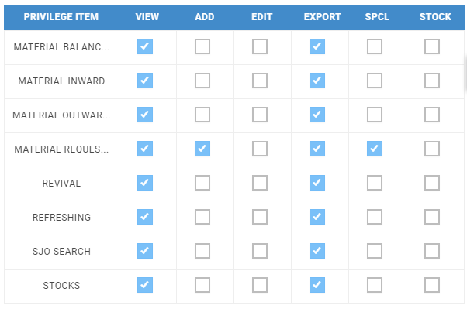

1. HO Coordinator can see and export all the FAM sub modules in his/her login.
2. HO Coordinator can raise a request to factory for material with specific quantity which is approved by Technical Service (TS).
3. For material request to factory, the only valid privileges are ADD and SPECIAL. Other than this a request to all the warehouses except factory can be made (For internal warehouse material request).
4. HO Coordinator can modify the request details and resend to MD/VP-Operations/VP-Finance when they reject the material.

## DYNAMIC LEVELS:

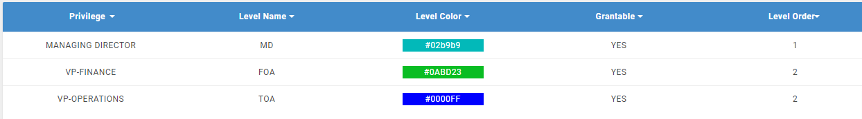

1. These levels are dynamic i.e., we can turn off as well as turned on the levels at any position.
2. We can change the order of the levels also.
3. For making the privileges dynamic, employee privileges are made SPECIAL in material request and these privileges are there in dynamic level table under settings also.
4. These privileged employees can take actions (approve OR reject OR hold) through mails also.

## MANAGING DIRECTOR:

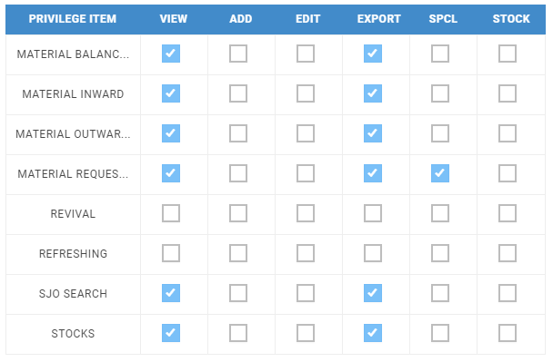

1. MD can approve/reject for all dynamic pending material request of new cells/revived cells and accessories.

## VP-FINANCE

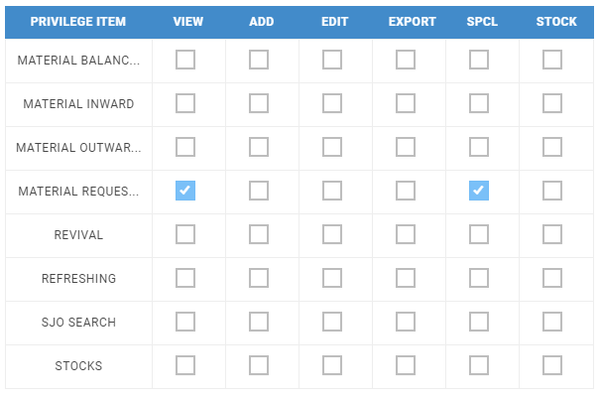

1. VP-Finance/VP-Operations can approve/reject dynamic pending material request for new cells only. Revived cells and accessories won’t be visible to these levels.
2. VP-Finance and VP-Operations are same level privilege employees in this dynamic level. If anyone approves /rejects or holds the request then no action is required from any other employee of the same privilege level.

## VP-OPERATIONS



1. VP-Finance/VP-Operations can approve/reject dynamic pending material request for new cells only. Revived cells and accessories are won’t be visible to these levels.
2. VP-Finance and VP-Operations are same level privilege employees in this dynamic level. If any one of them approves/rejects or holds the request then there is no action required by the other employee having the same privilege level.

## PPC

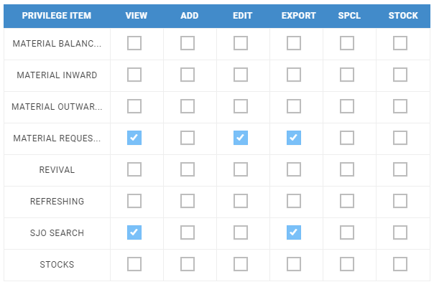

1. PPC can add the readiness date if the employee privileges are enabled as EDIT and ‘SPECIAL’ is disabled in MATERIAL REQUEST module.

## FACTORY QC

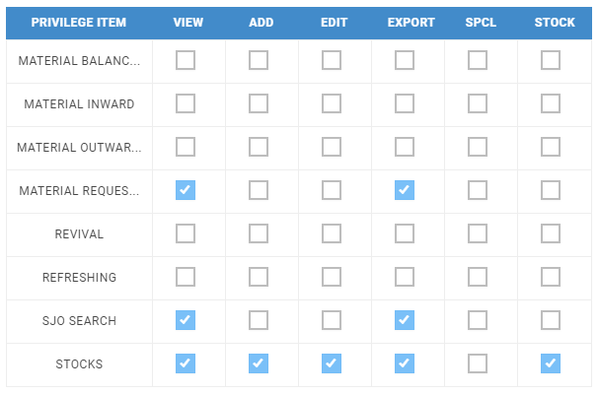

1. Stock can be added if the employee privileges are enabled as ADD and ‘SPECIAL’ is disabled in STOCK sub module. If SPECIAL is enabled, it works like FACTORY INVOICE.
2. If the stock is more than 500 then the system will ask to import the stock through excel.

## FACTORY INVOICE

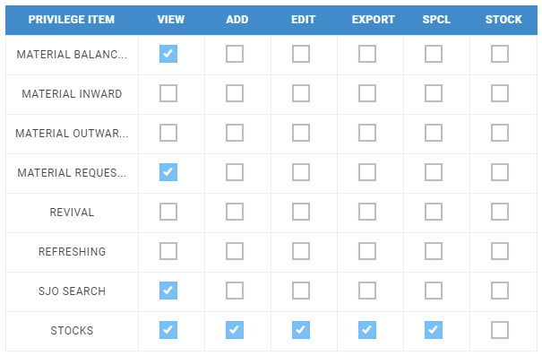

1. Invoice number and invoice date can be added if the employee privileges are enabled as SPECIAL in STOCK sub module. There is nothing that will change whether ADD is enabled or not.
2. Add button is visible even though ‘ADD’ is disabled in stock but SPECIAL should be enabled to show add button.

## FACTORY LOGISTIC

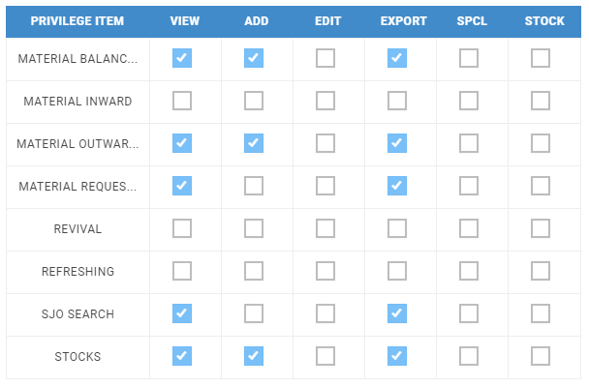

1. For logistic privilege, one must enable the ‘ADD’ in material outward and add only Factory in employee master warehouse list to get factory in material sending from drop down list.

## FACTORY SCRAP INWARD & TS

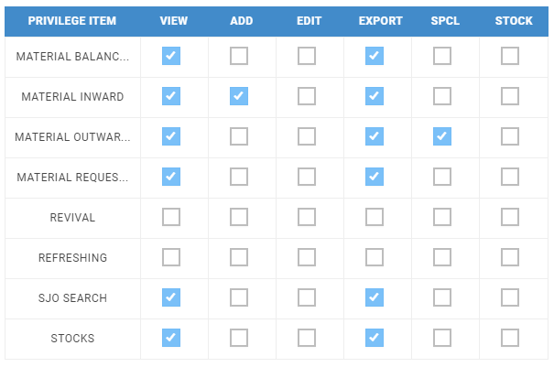

1. For scrap, inward privilege must enable the ADD in material inward and add only Factory in employee master warehouse.